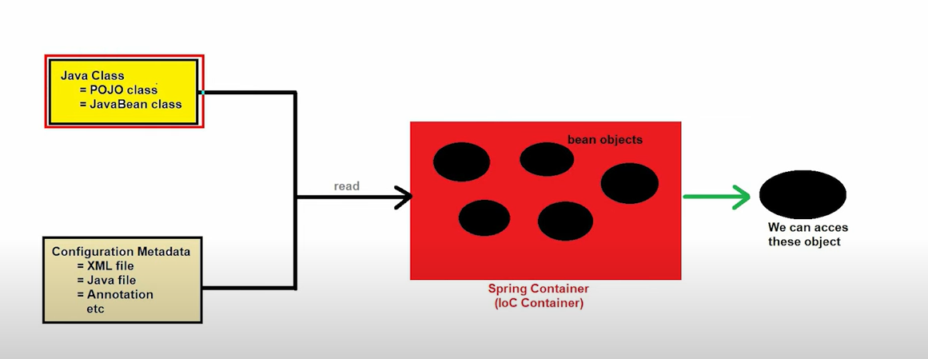

Life cycle

• **Instantiation**: The Spring container creates an instance of the bean.

**Example**: new Person()

• **Properties Setting**: The container injects values and dependencies into the bean’s properties.

**Example**: person.setName("Alice"); person.setAge(30);

• **Initialization**:

* The container applies any BeanPostProcessor callbacks before and after initialization.
* @PostConstruct or other custom initialization methods are called.

**Example**: person.initMethod() (if defined)

• **Usage**: The bean is fully initialized and ready for application use.

**Example**: Person person = context.getBean(Person.class);

• **Destruction**: When the container shuts down, any destruction methods, such as those annotated with @PreDestroy or custom methods, are called.

**Example**: person.destroyMethod() (if defined)